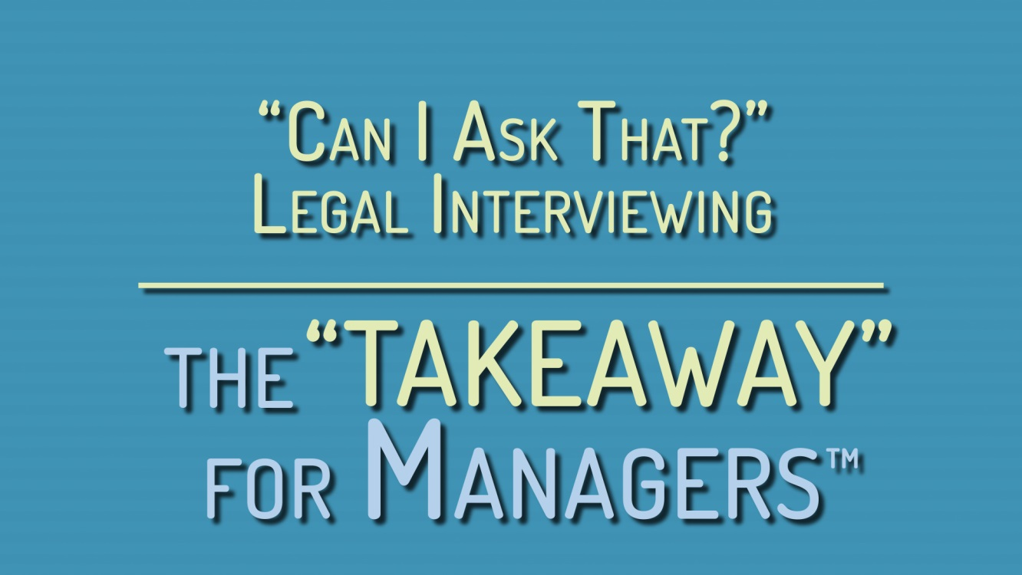

"Can I Ask That?" Legal Interviewing — the "TAKEAWAY" for Managers™

Leader’s Guide

Overview:

The four areas covered in "Can I Ask That?" Legal Interviewing — the "TAKEAWAY" for Managers™ —Questions Not to Ask and Why; How to Frame Your Questions; Respecting People’s Privacy; and Providing Reasonable Accommodation—are reinforced by four corresponding “takeaways,” information that’s especially important to come away with, summed up in an easy-to-remember sentence.

These four areas and their takeaways comprise the basic information that all managers and supervisors involved in the hiring process need in order to conduct a legally compliant interview. The "Can I Ask That?" Legal Interviewing — the "TAKEAWAY" for Managers™ program enables managers to interview with confidence.

Prepare for the Session:

- Preview the "Can I Ask That?" Legal Interviewing — the "TAKEAWAY" for Managers™ program, and consider how the four topics work together to ensure legal compliance during a job interview.

- Read through the Leader’s Guide.

- Make sure you have a Discussion Question handout for each participant.

- When discussing issues with legal ramifications such as how to conduct a legal interview, remember to reassure participants that they don’t need to be legal experts to grasp the material.

- Greet participants in a friendly manner.

Open the Session:

- Introduce yourself and welcome the participants to the training session.

- Introduce the "Can I Ask That?" Legal Interviewing — the "TAKEAWAY" for Managers™ program, explaining that it covers four key areas: Questions Not to Ask and Why; How to Frame Your Questions; Respecting People’s Privacy; and Providing Reasonable Accommodation.

- Ask participants as they watch the program to think about why these areas are important for managers to understand.

- Let participants know that there will be a short discussion portion of the program, with an opportunity to comment and/or ask questions.

- Show the "Can I Ask That?" Legal Interviewing — the "TAKEAWAY" for Managers™ program (running time: 10 minutes).

- Review the four topics and their corresponding takeaways as follows:

Questions Not to Ask and Why (Treat everyone the same.); How to Frame Your Questions (Keep it job-related to keep it legal.); Respecting People’s Privacy (Is that really relevant?); Providing Reasonable Accommodation (A small accommodation can have a big effect.)

Present the Material:

Topic 1: Questions Not to Ask and Why

Learning Points:

- It’s illegal to discriminate against an applicant based on race, color, religion, sex (including pregnancy, sexual orientation, and gender-identity), national origin (including citizenship and immigration status), age (if 40 or older), disability, genetic information, or political affiliation.

- Stay focused on the job requirements, and avoid personal questions that might be construed as discriminatory.

- Make sure you ask the same questions of all the candidates, male or female, younger or older, regardless of race, ethnicity, disability, religious attire, or accent.

The “TAKEAWAY”: Treat everyone the same.

Topic 2: How to Frame Your Questions

Learning Points:

- Frame your questions in such a way that they’re only about the applicant in relation to his or her suitability to perform the essential functions of the job.

- Do not ask leading questions to fish for information that’s not really relevant (such as When did you graduate? or Do you have children?).

- If an applicant volunteers inappropriate information, try not to let the information influence you, and steer the conversation back to the job requirements.

The “TAKEAWAY”: Keep it job-related to keep it legal.

Topic 3: Respecting People’s Privacy

Learning Points:

- Before you ask a question, think about whether it’s relevant.

- Don’t ask applicants for their social media passwords.

- Obtain written permission from applicants before investigating their credit history in compliance with the Fair Credit Reporting Act, or before looking into whether they have a criminal conviction.

The “TAKEAWAY”: Before you ask a question, ask yourself,
“Is that really relevant?”

Topic 4: Providing Reasonable Accommodation

Learning Points:

- The law requires employers to provide reasonable accommodation to disabled applicants and employees to allow them to apply or do a job.

- Accommodation that would be too expensive or difficult for the employer to provide is not considered “reasonable” and is therefore not legally required.

- Employers must also reasonably accommodate applicants’ and employees’ religious requirements (for instance, changing an interview time so that it doesn’t conflict with someone’s religious obligations).

The “TAKEAWAY”: A small accommodation can have a big effect.

Start Discussion:

- Distribute the Discussion Questions handout.

- Read the 4 questions on the Discussion Questions handout to participants, and explain that they will have 5–8 minutes for discussion based on the questions.

- Ask participants to take the handout Quiz.

- Have participants form small groups of 3–5 people for the discussion portion of the training.

Discussion Questions:

Why do you have to ask every applicant the same questions?

Sample answers:

- “It’s unfair and illegal to treat different categories of people in different ways.”
- “The law was made to give everyone equal opportunity.”
- “Only job-related questions are relevant, and those apply to everyone.”

How can you legally find out if applicants are qualified if you can’t ask them all about themselves?

Sample answers:

- “Only ask questions about whether they’re qualified.”
- “Ask everyone the same questions—ones that relate to the job.”
- “Frame your questions so that they would apply to all applicants.”

How can you make sure to respect applicants’ privacy?

Sample answers:

- “Before you ask a question, think about whether it’s relevant.”
- “Don’t ask them for their Facebook or other social media passwords.”
- “Don’t take or ask for a photo of job applicants before you hire them.”

What kind of accommodation might a manager provide to a job applicant?

Sample answers:

- “Letting the person bring her service dog to the interview.”
- “Holding the interview in a wheelchair-accessible room.”
- “Rescheduling an interview so that it’s not on the applicant’s religious holiday.”

Quiz Answer Key

- It’s okay to ask applicants whether they have children.
TRUE/FALSE

- Ask all applicants the same job-related questions.
TRUE/FALSE

- All questions should be about whether the candidate is qualified for the job.
TRUE/FALSE

- Employers don’t have to make even a very small accommodation for an applicant with a disability.
TRUE/FALSE

- You should obtain written permission before checking someone’s financial information.
TRUE/FALSE

- Don’t take or request a picture of an applicant before he or she is hired.
TRUE/FALSE

- Employers must provide reasonable accommodation for an applicant’s religious practice.
TRUE/FALSE

- It’s legal to ask applicants if they’re a citizen.
TRUE/FALSE

- It is illegal to ask applicants if they are legally allowed to work in this country.
TRUE/FALSE

- It’s a good idea to ask an applicant about his or her political affiliation.
TRUE/FALSE

Conclude the Session:

- Reassemble the group.

- Recap the following key concepts from "Can I Ask That?" Legal Interviewing — the "TAKEAWAY" for Managers™:

- Treat everyone the same.

- Keep it job-related to keep it legal.

- Is that really relevant?

- A small accommodation can have a big effect.

- Remind participants that the legal ins and outs of interviewing prospective employees are meant to give the most opportunity for employment to the most people, on as level a playing field as possible. They promote diverse and inclusive organizations, and help us find the best people for the job.

- Take questions.

5. Thank everyone for participating, and express your hope that participants will take what they’ve learned at the session and use it to conduct interviews that are inclusive and legally compliant.
"Can I Ask That?" Legal Interviewing —
the "TAKEAWAY" for Managers™
Handout

Discussion Questions

Why do you have to ask every applicant the same questions?

How can you legally find out if applicants are qualified if you can’t ask them all about themselves?

How can you make sure to respect applicants’ privacy?

What kind of accommodation might a manager provide to a job applicant?

Quiz

- It’s okay to ask applicants whether they have children.
TRUE/FALSE

- Ask all applicants the same job-related questions.
TRUE/FALSE

- All questions should be about whether the candidate is qualified for the job.
TRUE/FALSE

- Employers don’t have to make even a very small accommodation for an applicant with a disability.
TRUE/FALSE

- You should obtain written permission before checking someone’s financial information.
TRUE/FALSE

- Don’t take or request a picture of an applicant before he or she is hired.
TRUE/FALSE

- Employers must provide reasonable accommodation for an applicant’s religious practice.
TRUE/FALSE

- It’s legal to ask applicants if they’re a citizen.
TRUE/FALSE

- It is illegal to ask applicants if they are legally allowed to work in this country.
TRUE/FALSE

- It’s a good idea to ask an applicant about his or her political affiliation.
TRUE/FALSE

"Can I Ask That?" Legal Interviewing —
the "TAKEAWAY" for Managers™
Transcript

Keeping it legal can be surprisingly tricky for managers conducting a job interview. So that you don’t get your organization, or yourself, into hot water for violating federal and local anti-discrimination laws, let’s go over the four basics to keep your interviews legally compliant.

- Questions Not to Ask and Why
- How to Frame Your Questions
- Respecting People’s Privacy
- Providing Reasonable Accommodation

What is anti-discrimination law is all about? What are the questions not to ask, and why.

Questions Not to Ask and Why

Laws meant to protect us from discrimination in the workplace also apply to hiring. They were enacted to give the most people the most opportunity to be gainfully employed. So that we don’t allow prejudice and discrimination to creep into the workplace, and the hiring process, according to federal law, it’s illegal to discriminate against an applicant because of that person's race, color, religion, sex (including pregnancy, sexual orientation, and gender-identity), national origin (including citizenship and immigration status), age (if 40 or older), disability, or genetic information. It’s also illegal to discriminate based on political affiliation.
“WHERE ARE YOU FROM? ARE YOU A U.S. CITIZEN?”
“I BET SHE DOESN’T ASK EVERYONE THAT! I WISH WE COULD FOCUS ON MY QUALIFICATIONS INSTEAD OF MY ACCENT.”
“ARE YOU DISABLED?”
“EXCUSE ME?”
“I NEED TO KNOW IF SHE’S PHYSICALLY UP FOR THE JOB, DON’T I?”
“ARE YOU JEWISH?”
“I THINK JEWISH PEOPLE MIGHT HAVE A LOT OF RELIGIOUS OBLIGATIONS, SO THEY MIGHT NOT BE TOO FLEXIBLE WITH THEIR TIME.”
It’s illegal to ask applicants questions about how they fit into any of the protected categories covered by the law, because those things shouldn’t in themselves matter in terms of hiring.
When interviewing a potential employee, stay focused on the job requirements and avoid personal questions that might be construed as discriminatory.

And keep the spirit of the law in mind when you interview. Be as inclusive as possible, ask everyone the same questions, and keep an open mind. Casting a wide net when it comes to hiring will give you the best chance of finding great people.
Questions Not to Ask and Why
THE TAKEAWAY
Treat everyone the same.

So, if you can’t ask job candidates whether or not they’re a citizen, how will you know whether they can work here legally? If you can’t ask about disabilities, how will you know whether they can physically do the job? If you don’t ask about religious affiliation how will you know whether they can work on certain days of the week or holidays?
Framing your questions to keep them legal is the answer to getting the information you need while staying legally compliant.

How to Frame Your Questions
Frame your questions in such a way that they’re only about the applicant in relation to his or her suitability to perform the essential functions of the job, and skip the personal stuff.
And—and this is important— make sure you ask the same questions of all the candidates, male or female, younger or older, regardless of race, ethnicity, disability, religious attire, or accent—without bias.
“CAN YOU PROVIDE DOCUMENTATION THAT VERIFIES YOU CAN LEGALLY WORK IN THIS COUNTRY?”
“YES, I CAN. IN FACT, I HAVE IT WITH ME.”
“THE JOB REQUIRES SITTING FOR LONG PERIODS. ARE YOU ABLE TO DO THAT?”
“YES, THAT’S NOT A PROBLEM.”
“SOMETIMES WE REQUIRE OVERTIME. CAN YOU WORK ON SATURDAYS?”
“I WON’T BE ABLE TO WORK ON SATURDAYS FOR RELIGIOUS REASONS, BUT I COULD WORK LATE FROM MONDAY TO THURSDAY, OR ON SUNDAYS, IF YOU NEEDED ME TO.”
But what if you’ve been diligent about avoiding illegal, discriminatory questions on the application, or in the interview, but the applicant includes some inappropriate information in his or her résumé or brings it up in conversation?
Just try not to let the information influence you, steer the conversation back to the job requirements, and don’t include the unsolicited information in your notes, which can be used in a discrimination lawsuit.

“I SPEAK SPANISH FLUENTLY. I WAS BORN IN GUATEMALA.”
“AS YOU CAN SEE IN THE JOB DESCRIPTION, PROFICIENCY IN BOTH IN ENGLISH AND SPANISH IS JUST WHAT WE NEED. WHAT KIND OF COMPUTER SKILLS DO YOU HAVE?”
You can get the information you need, and do it legally, if you stick to the job requirements and frame your questions with care.
How to Frame Your Questions
THE TAKEAWAY
Keep it job-related to keep it legal.

Don’t ask applicants about their family medical history, military service (unless their military experience pertains specifically to the job), their children, where they were born, or whether they have an arrest record. When interviewing, it’s important to think about respecting people’s privacy.
Respecting People’s Privacy

You may, however, ask applicants if they have been convicted of a crime—that is, if it’s relevant to the job, and you ask all the candidates, not just certain categories of people. You may also ask about illegal drug use, but not about prescription drugs, and, once again, only if you ask everyone interviewing.
“BECAUSE OF THE SENSITIVE NATURE OF OUR BUSINESS, WE’RE ASKING ALL THE APPLICANTS IF THEY’VE BEEN CONVICTED OF A CRIME. HAVE YOU?”
“NO, I HAVEN’T.”
“HE ASKED ME IF I’VE EVER BEEN CONVICTED OF A CRIME. I WOULD HAVE ASSUMED THAT HE WAS BEING RACIST, BUT HE EXPLAINED WHY THEY HAD TO ASK EVERYBODY THAT QUESTION, AND IT MADE SENSE.”
Don’t ask applicants personal questions, like the year they graduated from school (a way of deducing someone’s age), or what clubs they belong to. These questions aren’t job-related, and they may be the basis for discrimination. Also, don’t ask applicants for their social media passwords, a practice illegal in many states, or for a photograph of themselves. If a photo is needed for employee identification, ask for it after the person is hired, not before.
“WE LIKE TO GET TO KNOW OUR APPLICANTS AS MUCH AS POSSIBLE. WOULD YOU MIND FILLING IN THIS QUESTIONNAIRE, AND DON’T FORGET TO INCLUDE YOUR FACEBOOK PASSWORD.”
“ACTUALLY, I DON’T KNOW IF I’M COMFORTABLE WITH THAT.”
“OH, DON’T WORRY ABOUT IT. IT’LL JUST GO IN THE FILE.”
“MY FACEBOOK PASSWORD? NOT COOL!”
An employer may look into candidates’ credit history, if doing so has some bearing on the job, all candidates are subject to the same scrutiny, and the employer does so in compliance with the Fair Credit Reporting Act. But applicants should be notified first, and their written permission obtained, if the employer is going to check their financial information.
Respecting People’s Privacy

THE TAKEAWAY
Before you ask a question, ask yourself, “Is that really relevant?”

It’s important for manager’s to have some guidelines for providing reasonable accommodation. The law requires an employer to provide any reasonable accommodation necessary to allow a disabled candidate to apply for a job, unless doing so would cause significant difficulty or expense for the employer. The law also requires that an employer reasonably accommodate someone’s religious practice.
Providing Reasonable Accommodation
A “reasonable accommodation” is any change in the workplace (or in the ways things are usually done) to help a person with a disability or particular religious practice to apply for a job, perform the duties of a job, or enjoy the benefits and privileges of employment.
“JENNY. LET’S INTERVIEW GEORGE IN CONFERENCE ROOM B INSTEAD OF THE ONE WE’VE BEEN USING. THAT DOORWAY IS TOO NARROW FOR HIS WHEELCHAIR.”
“GOOD IDEA. THE ROOM IS FREE NOW.”
“GREAT.”
“THEY WERE REALLY NICE ABOUT ACCOMMODATING ME, AND I KNOW I’D BE PERFECT FOR THIS JOB!”
Reasonable accommodation for an applicant at an interview might include, for example, providing a ramp for a wheelchair user or providing a reader or interpreter for someone who is blind or deaf.
Providing Reasonable Accommodation
THE TAKEAWAY
A small accommodation can have a big effect.

All these legal requirements and prohibitions are meant to give the most opportunity for employment to the most people, on as level a playing field as possible. They promote diverse and inclusive organizations, which benefit us all. If you avoid discriminatory questions and treat all applicants the same, frame your questions in a way that keeps them legal, respect people’s privacy, and provide reasonable accommodation if needed, you’ll protect your organization, and yourself, from legal liability. And you’ll have the best chance of finding the best person for the job.

